THE STUDY OF AEROSOL COMPONENT OF ATMOSPHERE IN BRATISLAVA

I. Sýkora, J. Merešová, M. Chudý, K. Holá
Department of Nuclear Physics, Comenius University, Mlynská dolina F1, 842 48 Bratislava, Slovakia

Introduction
Atmospheric aerosols are submicron particles, on which the elements of solid or liquid state present in the atmosphere are captured. Also radioactive nuclides are being bound to them. Aerosol particles are sorted according their size into small-dispersive (d < 0.1 μm), middle-dispersive (0.1 < d < 10 μm) and big-dispersive (d > 10 μm). The latter are staying only short time in the atmosphere, due to gravitation they are quickly falling on the Earth’s surface.
Most important radionuclides present in the low-level atmosphere are ²²²Rn, its short-lived and long-lived progeny ²¹⁰Pb and ²¹⁰Po. ²²²Rn originates from the decay chain of ²³⁸U, which is present in terrestrial crust. In comparable concentration to ²¹⁰Pb and ²¹⁰Po, the cosmogenic ⁷Be is present in the low-level atmosphere. Antropogenic ¹³⁷Cs, coming mainly from nuclear bomb tests and Chernobyl accident, and primordial ⁴⁰K are present in very low concentrations in the atmosphere.
The aim of this study is to continue in the long-term measurement of radioactivity of aerosol component in low level atmosphere in Bratislava [1]. In particular our work is concerned with ²¹⁰Pb, ⁷Be, ¹³⁷Cs and ⁴⁰K measurements.

Experimental
Aerosol particles in the atmosphere have been collected using the nitro-cellulose filters (PRAGOPOR – with hole diameter 0.8 μm) with the collection efficiency of approximately 100 %. Aerosol samples have been collected at Meteorological Station near the Faculty of Mathematics, Physics and Informatics in Bratislava. After exposing in a sampler device the filters have been measured by a semiconductor HPGe detector with a beryllium window placed in the low-background shield. Corrections for radioactive decay were applied on the obtained values.
In case of ¹³⁷Cs and ⁴⁰K because of their very low concentrations two or more sets of samples were accumulated together to obtain flow volumes on 10000 m³ level. These accumulated samples have been measured by a large volume HPGe detector with higher detection efficiency, than in the first case, placed also in low background shielding.
Simultaneously, the local meteorological data (wind velocity, air temperature, air pressure, air humidity and amount of precipitation) have been recorded.

Results and Discussion

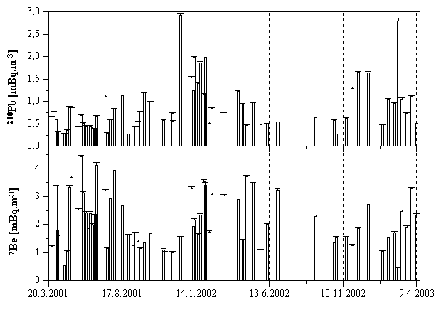
During monitoring period from March 2001 to April 2003 68 sets of nitro-cellulose filters were sampled. Measured concentrations of ²¹⁰Pb and ⁷Be over the term are presented in figure 1. The concentrations of ²¹⁰Pb ranged from 0.27 to 2.93 mBq.m⁻³ with a mean value 0.87 ± 0.02 mBq.m⁻³. The concentrations of ⁷Be ranged from 0.46 to 4.42 mBq.m⁻³ with a mean value 2.14 ± 0.04 mBq.m⁻³. Both radionuclides show seasonal variations. ²¹⁰Pb reach higher values in autumn and winter months, what is attributed to a frequent inversion conditions of the surface air layers [7]. The decrease of the ²¹⁰Pb concentration in warm spring and summer season is a result of intensive air mixing. The concentration of ⁷Be behaves almost inversely to the ²¹⁰Pb concentration. The highest values of activity have been detected during spring and summer term. It is an effect of air-mass transport from stratosphere to troposphere. On the contrary in cold months these exchange processes are reduced and as a result the supply of ⁷Be produced in higher layers of atmosphere declines.
Fig. 1. Air activity concentrations of ²¹⁰Pb and ⁷Be in aerosol component of the atmosphere.

Correlation coefficients between air concentrations of radionuclides and meteorological parameters are presented in table 1. Relatively strong correlation between the concentrations of ²¹⁰Pb and air pressure is observable. This result is astonishing considering between radon progeny and the atmospheric pressure the opposite trend was observed [6]. Also relatively strong anti-correlation of air temperature with the ²¹⁰Pb concentration is apparent. The increasing air temperature induced stronger air mixing [8] what effects remarkable decrease of ²¹⁰Pb concentration. In case of the ⁷Be there was not found out any significant correlation with meteorological parameters.

Table 1
Correlation coefficients between air concentrations of radionuclides and meteorological parameters
 | Wind velocity | Air temperature | Air pressure | Air humidity | Precipitation
²¹⁰Pb | -0.30 | -0.51 | 0.59 | 0.35 | -0.22
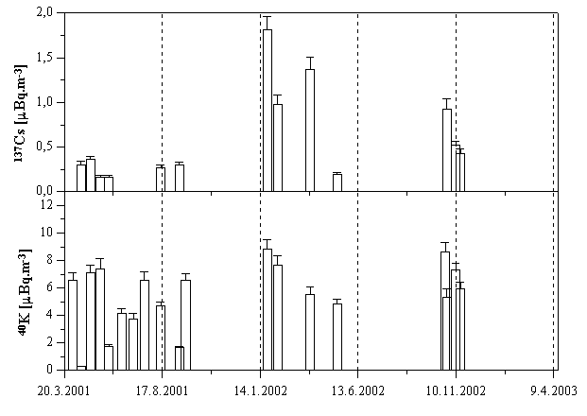  ⁷Be  Fig. 2. Air activity concentrations of ¹³⁷Cs and ⁴⁰K in aerosol component of the atmosphere. | 0.07 | 0.25 | 0.07 | -0.39 | -0.21
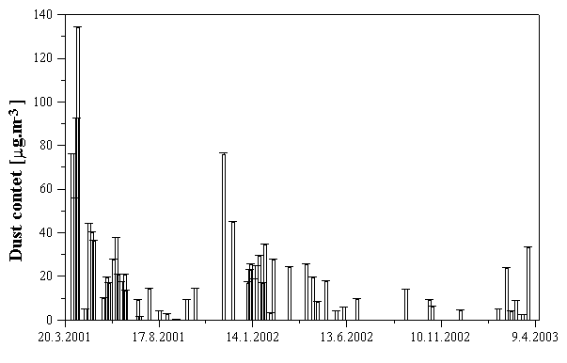
¹³⁷Cs and ⁴⁰K in atmospheric aerosol have very low concentrations. The results of air activity concentration measurements are presented in figure 2. For ¹³⁷Cs only 13 and for ⁴⁰K only 19 samples reached the activity concentration above detection limit. Values of the activity concentration of ¹³⁷Cs ranged from 0.16 to 1.81 μBq.m⁻³ with mean value 0.6 ± 0.06 μBq.m⁻³. For ⁴⁰K the concentration ranged from 0.28 to 8.83 μBq.m⁻³ with mean value 5.5 ± 0.46 μBq.m⁻³.
Fig. 3. Dust content collected on aerosol filters.

Also the mass of dust content for every filter sample have been measured. The results are shown in figure 3 and the values ranged from 0.23 to 134 μg.m⁻³, what are typical amounts for European area [2].

Conclusion
The concentrations of ²¹⁰Pb and ⁷Be ranged from 0.27 to 2.93 mBq.m⁻³ with a mean value 0.87 ± 0.02 mBq.m⁻³ and from 0.46 to 4.42 mBq.m⁻³ with a mean value 2.14 ± 0.04 mBq.m⁻³, respectively. Both radionuclides show seasonal variations. The concentrations of ¹³⁷Cs and ⁴⁰K are near detection limit. It is a reason why only few data have been evaluated. The mean value of ¹³⁷Cs and ⁴⁰K is 0.6 ± 0.06 μBq.m⁻³ and 5.5 ± 0.46 μBq.m⁻³, respectively. Activity of aerosol component of low level atmosphere in Bratislava shows typical values of air activity concentrations of ²¹⁰Pb, ⁷Be, ¹³⁷Cs and ⁴⁰K for European area [2, 3, 4 and 5].

Acknowledgements
This study was funded by Scientific Grant Agency of Ministry of Education of Slovak Republic (VEGA project No. 1/7653/20, 1/0246/03) and by Comenius University (grant No. UK/25/2003).

References
[1] L. Ďurana, M. Chudý, J. Masarik, Investigation of ⁷Be in Bratislava atmosphere. Journal of Radioanalyt. and Nucl. Chemistry 207 (1996), 345-356
[2] R. Winkler, F. Dietl, G. Frank, J. Tschiersch, Temporal variation of ⁷Be and ²¹⁰Pb size distributions in ambient aerosol. Atmospheric Environment 32 (1998), 983-991.
[3] D. Todorovic, D. Popovic, G. Djuric, M. Radenkovic, ²¹⁰Pb in ground-level air in Belgrade city area. Atmospheric Environment 34 (2000), 3245-3248.
[4] I. Sýkora, M. Chudý, L. Ďurana, K. Holý, J. Merešová, Aerosols radioactivity in the Bratislava atmosphere. XXIV. Days of Radiation Protection 2001, (Conf. Proc. of the 24th DRP, Jasná pod Chopkom, Slovakia, 2001), 145-147.
[5] G. Rosner, H. Hötzl, R. Winkler, Continuous Wet-only and Dry-only Deposition Measurements of ¹³⁷Cs and ⁷Be: an Indicator of their Origin. Applied Radiation and Isotopes 47 (1995), 1135-1139.
[6] C. Dueñas, M. C. Fernándes, M. Senciales, Usefulness of Rn, decay products of Rn and Th B to study diffusion in the lower atmosphere. Atmospheric Environment 24 (1990), 1255-1261.
[7] K. Holý, R. Böhm, I. Bosá, A. Polášková, O. Holá, ²²²Rn concentration in the outdoor atmosphere and its relation to the atmospheric stability. Radiation Hygiene Days 1998 (Conf. proc. of the 21st RHD, Jasná pod Chopkom, Slovakia, 1998), 213-216.
[8] K. Holý, I. Bosá, R. Böhm, A. Polášková, O. Holá, Analysis of the daily ²²²Rn courses in the surface layer of the atmosphere. 3. Banskoštiavnické dni 2001 (Conf. proc. Banská Štiavnica, 2001), 105-118.

